Anticipation Guide (Level 2): Holes by Louis Sachar
Answer the Statements previous to reading. Reassess your answer when you are finished reading the novel.

Name: ______________________________________ Date: ____________

Yes/No | Statement/Question | Yes/No
Should people be judged based on appearance?
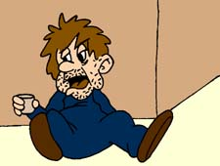
 | Should people be judged based on what they’ve done?
Is physical labor an acceptable form of punishment?
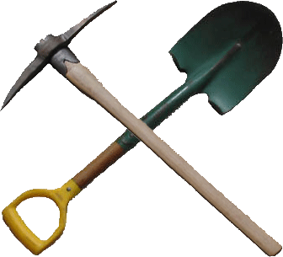

Do those who lived before you determine the path of your life?
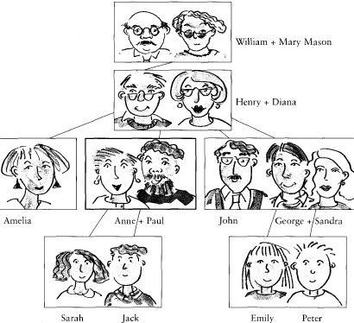

Do people act differently in groups than they do by themselves?
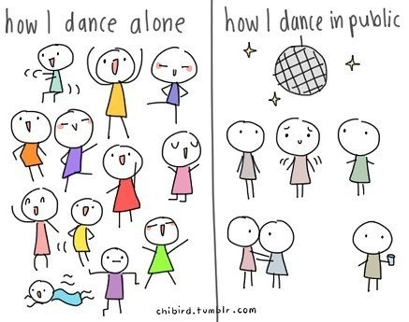

Anticipation Guide (Level 3): Holes by Louis Sachar
Answer the Statements previous to reading. Reassess your answer when you are finished reading the novel.

Name: ______________________________________ Date: ____________

Yes/No | Statement/Question | Yes/No
 | Should people be judged based on appearance?
 | Should people be judged based on what they’ve done?
 | Is physical labor an acceptable form of punishment?
 | Do those who lived before you determine the path of your life?
 | Do people act differently in groups than they do by themselves?

Anticipation Guide (Level 4): Holes by Louis Sachar
Answer the Statements previous to reading. Reassess your answer when you are finished reading the novel.

Name: ______________________________________ Date: ____________

Yes/No | Statement/Question | Yes/No
Should people be judged based on appearance?
Explain:

Should people be judged based on what they’ve done?
Explain:

Is physical labor an acceptable form of punishment?
Explain:

Do those who lived before you determine the path of your life?
Explain:

Do people act differently in groups than they do by themselves?
Explain:

